Multi-tier (N-tier) Systems
# Source: Chatgpt (GPT-5-Mini) at [1/16/2026]
A Multi-tier (N-tier) system is a type of distributed system architecture in which an application is divided into more than three layers (tiers), where each tier has a specific responsibility and can be deployed on separate servers.
N means any number of tiers (4-tier, 5-tier, etc.).

Definition
# Source: Chatgpt (GPT-5-Mini) at [1/16/2026]
In a Multi-tier (N-tier) system:
- Application components are logically and physically separated
- Each tier communicates only with adjacent tiers
- Tiers can be independently developed, deployed, and scaled

General Architecture Diagram
# Source: Chatgpt (GPT-5-Mini) at [1/16/2026]
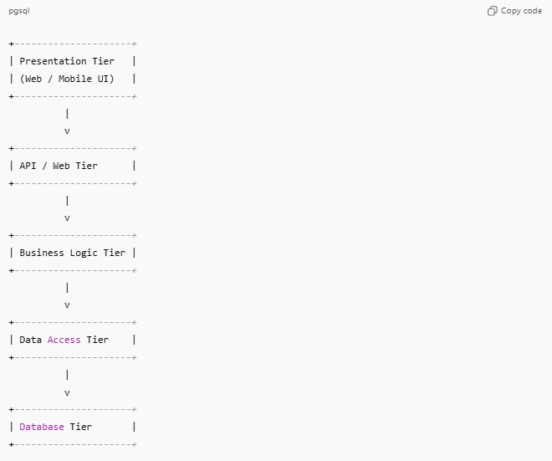
+---------------------+
| Presentation Tier |
| (Web / Mobile UI) |
+---------------------+
|
v
+---------------------+
| API / Web Tier |
+---------------------+
|
v
+---------------------+
| Business Logic Tier |
+---------------------+
|
v
+---------------------+
| Data Access Tier |
+---------------------+
|
v
+---------------------+
| Database Tier |
+---------------------+

Common Tiers Explained
# Source: Chatgpt (GPT-5-Mini) at [1/16/2026]
1. Presentation Tier
- User interface
- Displays data and collects input
Example: Web browser, mobile app
2. Web / API Tier
- Handles HTTP requests
- Authentication, routing, rate-limiting
Example: REST APIs, web servers
3. Business Logic Tier
- Core application rules and processing
Example: Order processing, payment validation
4. Data Access Tier
- Communicates with databases
- Executes queries, ORM logic
5. Data Tier
- Stores persistent data
Example: SQL / NoSQL databases

How It Works
# Source: Chatgpt (GPT-5-Mini) at [1/16/2026]
- User interacts with the presentation tier
- Request flows through multiple tiers
- Each tier performs a specific function
- Response is sent back through the tiers to the user

Real-World Examples
# Source: Chatgpt (GPT-5-Mini) at [1/16/2026]
- Large e-commerce platforms (Amazon)
- Enterprise resource planning (ERP) systems
- Banking and insurance applications
- Large SaaS applications

Advantages
# Source: Chatgpt (GPT-5-Mini) at [1/16/2026]
- High scalability (each tier scales independently)
- Improved security (database deeply isolated)
- Better maintainability
- Fault isolation (failure in one tier doesn’t crash entire system)

Disadvantages
# Source: Chatgpt (GPT-5-Mini) at [1/16/2026]
- Increased system complexity
- Higher development and infrastructure costs
- More network communication → possible latency

Comparison: Two-Tier vs Three-Tier vs N-Tier
# Source: Chatgpt (GPT-5-Mini) at [1/16/2026]
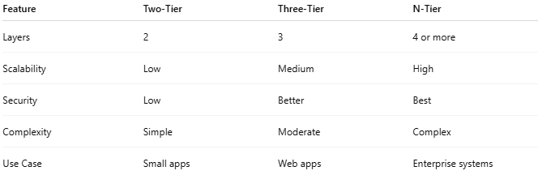
Feature | Two-Tier | Three-Tier | N-Tier
Layers | 2 | 3 | 4 or more
Scalability | Low | Medium | High
Security | Low | Better | Best
Complexity | Simple | Moderate | Complex
Use Case | Small apps | Web apps | Enterprise systems

Simple Analogy
# Source: Chatgpt (GPT-5-Mini) at [1/16/2026]
- N-Tier system = Large company with multiple departments
  - Reception → Manager → Accountant → Warehouse → Database
Each department does one job only, making the organization efficient.

